EduVision — Ranking Almanac
QS + THE Combined University Ranking Analysis

FINAL PROJECT REPORT

Project | University Ranking Analytics using QS and THE data
Prepared By | Swathapriya Kakkarla
Program | B.Tech — Computer Science & Engineering
Institution | CMR Technical Campus, Hyderabad
Analytics Platform | Tableau

Dataset used for analysis: 933 records × 58 fields

Executive Summary
EduVision is a university ranking analytics project that combines QS and Times Higher Education (THE) ranking information into an interactive Tableau reporting solution. The project focuses on transforming raw university ranking data into structured analytical views covering overall ranking, research performance, student characteristics, and country-level comparison.
The final solution contains four interconnected Tableau dashboards: University Overview, Research Analytics, Student Analytics, and Country Comparison. Each dashboard uses KPIs, filters, and multiple visualization types to support exploration of university performance from different perspectives.
The cleaned dataset used for the final dashboards contains 933 records and 58 fields. The dataset covers 89 countries based on the country field used in the analysis.
The report follows the structure of the supplied reference project report: background and problem statement, objectives, technology stack, methodology, module-wise development, dashboard evidence, technical implementation, results, limitations, future scope, and conclusion.

Table of Contents
- 1. Project Background and Problem Statement
- 2. Objectives and Scope
- 3. Dataset and Data Preparation
- 4. Technology Stack
- 5. Project Methodology and Workflow
- 6. Module-wise Development
- 7. Dashboard Design and Analytics
- 8. Dashboard Screenshots and User Interface Evidence
- 9. KPI Design
- 10. Technical Implementation
- 11. Results and Key Observations
- 12. Limitations
- 13. Future Scope
- 14. Conclusion

1. Project Background and Problem Statement
University ranking data is published using multiple ranking systems, indicators, categories, and institutional attributes. When information from QS and THE is viewed separately, it can be difficult to compare institutions, understand differences between ranking systems, identify research patterns, and examine country-level distribution.
The project addresses this analytical problem by creating a consolidated dataset and an interactive Tableau dashboard suite. The dashboards provide a single visual environment for comparing ranking positions, scores, research indicators, student population characteristics, institution size, and country-level patterns.

Problem Statement
- University ranking information is distributed across multiple ranking indicators and fields.
- Direct comparison of QS and THE positions can be difficult when rank ranges and unavailable rankings are present.
- Research, student, and country-level indicators need separate analytical views for easier interpretation.
- Static tables do not provide the same level of interactive filtering and visual exploration as dashboards.
- A unified analytics solution is required to present KPIs, comparisons, distributions, and geographic patterns.

Project Theme
The project is centered on data analytics and business intelligence: collect and prepare ranking data, derive analysis-ready fields, calculate KPIs, create visualizations, and assemble them into interactive Tableau dashboards.

2. Objectives and Scope

Objectives
- Collect and organize university ranking data for QS and THE.
- Clean ranking fields and create analysis-ready numeric rank values.
- Compare QS and THE ranking positions and identify ranking differences.
- Analyze research indicators including research, citation, teaching, and industry-income scores.
- Analyze student population, institution size, faculty-student indicators, and student-staff ratios.
- Compare universities and countries through interactive visualizations.
- Build four Tableau dashboards with KPIs, filters, and diverse chart types.
- Provide a consolidated analytical view that can be used for presentation and decision support.

Scope
- QS and THE university ranking data.
- University, country, ranking, score, research, student, and institution-size attributes available in the dataset.
- Four Tableau dashboards and their supporting worksheets.
- Python-based data collection/processing and KPI calculation scripts.
- Interactive filtering by university, country, rank category, and institution size where applicable.

3. Dataset and Data Preparation
The final cleaned dataset contains 933 rows and 58 columns. The project uses fields covering QS ranking, THE ranking, overall scores, research indicators, student statistics, institution size, country, and derived comparison fields.

Major Data Groups
Data Group | Fields / Purpose
QS Ranking | QS 2025/2024 rank, QS overall score, academic reputation, employer reputation, faculty-student indicator, citations, international indicators.
THE Ranking | THE rank, overall score, teaching, research, citations, industry income, and international outlook indicators.
Student Analytics | Student population, student-staff ratio, institution size, and international student-related fields where available.
Geographic Analysis | Country/location fields used for maps and country comparison.
Derived Fields | Clean numeric ranks, rank categories, rank difference, absolute rank difference, ranking comparison, academic reputation score, faculty-student ratio score, and global score.

Data Preparation Process
- Load the merged university ranking data.
- Standardize column names and clean university-name text.
- Remove duplicate records.
- Convert QS and THE rank values into usable numeric fields while retaining original rank bands.
- Create a unified university-name field.
- Calculate QS–THE rank difference and absolute rank difference.
- Create ranking categories such as Top 10, 11–50, 51–100, 101–500, Above 500, and Unknown.
- Create the QS/THE ranking comparison classification.
- Validate missing values and prepare fields used by the Tableau dashboards.
- Export the final cleaned dataset for dashboard development.

4. Technology Stack
Technology | Role in Project
Python | Data loading, cleaning, transformation, KPI calculations, and analytical chart generation.
Pandas | Tabular data manipulation and preprocessing.
NumPy | Numeric processing used in analytical calculations.
Matplotlib / Seaborn | Exploratory visualizations and chart generation during analysis.
Excel / CSV | Raw and cleaned data storage and exchange.
Tableau | Interactive dashboards, KPIs, filters, maps, and analytical visualizations.

5. Project Methodology and Workflow
The project follows a staged analytics workflow in which raw ranking data is transformed into a validated analysis dataset and then presented through interactive dashboards.
Raw university ranking data
↓
Data collection / loading
↓
Data cleaning and standardization
↓
Rank parsing and derived-field creation
↓
KPI calculations and analytical validation
↓
Tableau data connection
↓
Worksheet and visualization development
↓
Dashboard assembly and formatting
↓
Final dashboard review and presentation
6. Module-wise Development

Module 1 — Data Collection
The first stage establishes the raw university ranking dataset. The data collection script is maintained separately as data_collection.py and is intended to load the raw source and produce the raw CSV used for subsequent processing.
- Raw source: university ranking dataset.
- Script: data_collection.py.
- Output: university_raw_data.csv.
- Purpose: preserve the raw data before cleaning and transformation.

Module 2 — Data Cleaning and Preparation
The second stage prepares the ranking data for analysis. The main analysis script standardizes fields, cleans names, removes duplicates, parses rank values, creates categories, calculates ranking differences, and exports the cleaned dataset.
- Standardize field names.
- Clean university names.
- Remove duplicate records.
- Create qs_rank_clean and the_rank_clean.
- Create qs_rank_category and the_rank_category.
- Create rank_difference and absolute_rank_difference.
- Create ranking_comparison.
- Validate the final dataset before Tableau use.

Module 3 — KPI and Analytical Calculations
The KPI stage adds analytical fields used by the dashboards. The KPI calculation script includes Academic Reputation Score, Faculty-to-Student Ratio Score, and Global Score fields and saves the enriched dataset for downstream analysis.
- Academic Reputation Score is derived from the QS academic reputation indicator.
- Faculty-to-Student Ratio Score is derived from the QS faculty-student indicator.
- Global Score is calculated from weighted QS indicator fields.
- The enriched dataset is exported to Excel and CSV for dashboard use.

Module 4 — Tableau Dashboard Development
The fourth stage converts the prepared dataset into four interactive dashboards. The dashboard suite follows a common EduVision visual language and provides navigation between the four analytical areas.
- University Overview — overall ranking and institutional overview.
- Research Analytics — research, citation, teaching, and industry-income analysis.
- Student Analytics — student population, size, faculty/student, and student-staff analysis.
- Country Comparison — QS/THE ranking comparison and geographic analysis.

7. Dashboard Design and Analytics

7.1 University Overview
Provides a high-level view of university rankings, global score, academic reputation, institution size, and rank-versus-score relationships.
- Top University Rankings — Bar chart
- Global University Distribution — Treemap
- Academic Reputation Analysis — Pie chart
- Performance Comparison — Line chart
- Institution Size — Bubble chart
- Rank vs Score — Scatter plot
KPIs: Total Countries / Total Universities • Average QS Score • Average THE Score • Average Global Score

7.2 Research Analytics
Focuses on research performance and supporting indicators from the THE and QS data.
- Top Research Universities — Bar chart
- Citation vs Research Impact — Scatter plot
- Regional Research — Treemap
- Industry vs Teaching — Bubble chart
- Top Citation Universities — Lollipop chart
- Research Score Distribution — Histogram
KPIs: Average Citation Score • Average Research Score • Average Industry Income • Total Universities

7.3 Student Analytics
Examines student population, institution size, faculty-student relationships, student-staff ratio, and geographic student patterns.
- Universities by Student Number — Bar chart
- International Student Score by Country — Map
- Institution Size Distribution — Pie chart
- Student Population vs Faculty Ratio — Bubble chart
- Student-Staff Ratio by Country — Lollipop chart
- Student Population by Institution — Heat map
KPIs: Total Student Population • Average Faculty-Student Index • Average Student-Staff Ratio • Total Universities

7.4 Country Comparison
Compares QS and THE rankings at country and university levels and provides geographic and ranking-difference views.

- QS vs THE Ranking by Country — Grouped bar chart
- QS vs THE Score — Scatter plot
- University Distribution — Treemap
- Global Score by Country — Bubble / map view
- QS–THE Rank Difference — Lollipop chart
- Ranking Comparison by Country — Heat map
KPIs: Total Countries • Average QS Rank • Average THE Rank • Average Global Score

9. KPI Design
KPIs are presented as compact summary cards at the top of each dashboard. They provide an immediate numerical view of the dashboard's main analytical dimensions and respond to the active dashboard filters.
KPI | Calculation / Field | Purpose
Total Universities | COUNTD(university_name) | Counts distinct institutions.
Average QS Rank | AVG(qs_rank_clean) | Shows the average numeric QS ranking position.
Average THE Rank | AVG(the_rank_clean) | Shows the average numeric THE ranking position.
Average Global Score | AVG(global_score) | Summarizes the calculated global score.

KPI | Calculation / Field | Purpose
Average Citation Score | AVG(the_scores_citations) | Research/citation indicator summary.
Average Research Score | AVG(unnamed_22) | Research score summary used in the dataset.
Average Industry Income | AVG(the_scores_industry_income) | Industry-income indicator summary.
Total Universities | COUNTD(university_name) | Distinct university count.

Note: Ranking numbers are positional values, so a smaller numeric rank represents a higher ranking position. This distinction is important when interpreting average rank values and rank differences.

8. Dashboard Screenshots and User Interface Evidence
The following screenshots document the four completed Tableau dashboards. They show the navigation structure, filters, KPI cards, visualizations, and dashboard-level layout used in the final project.
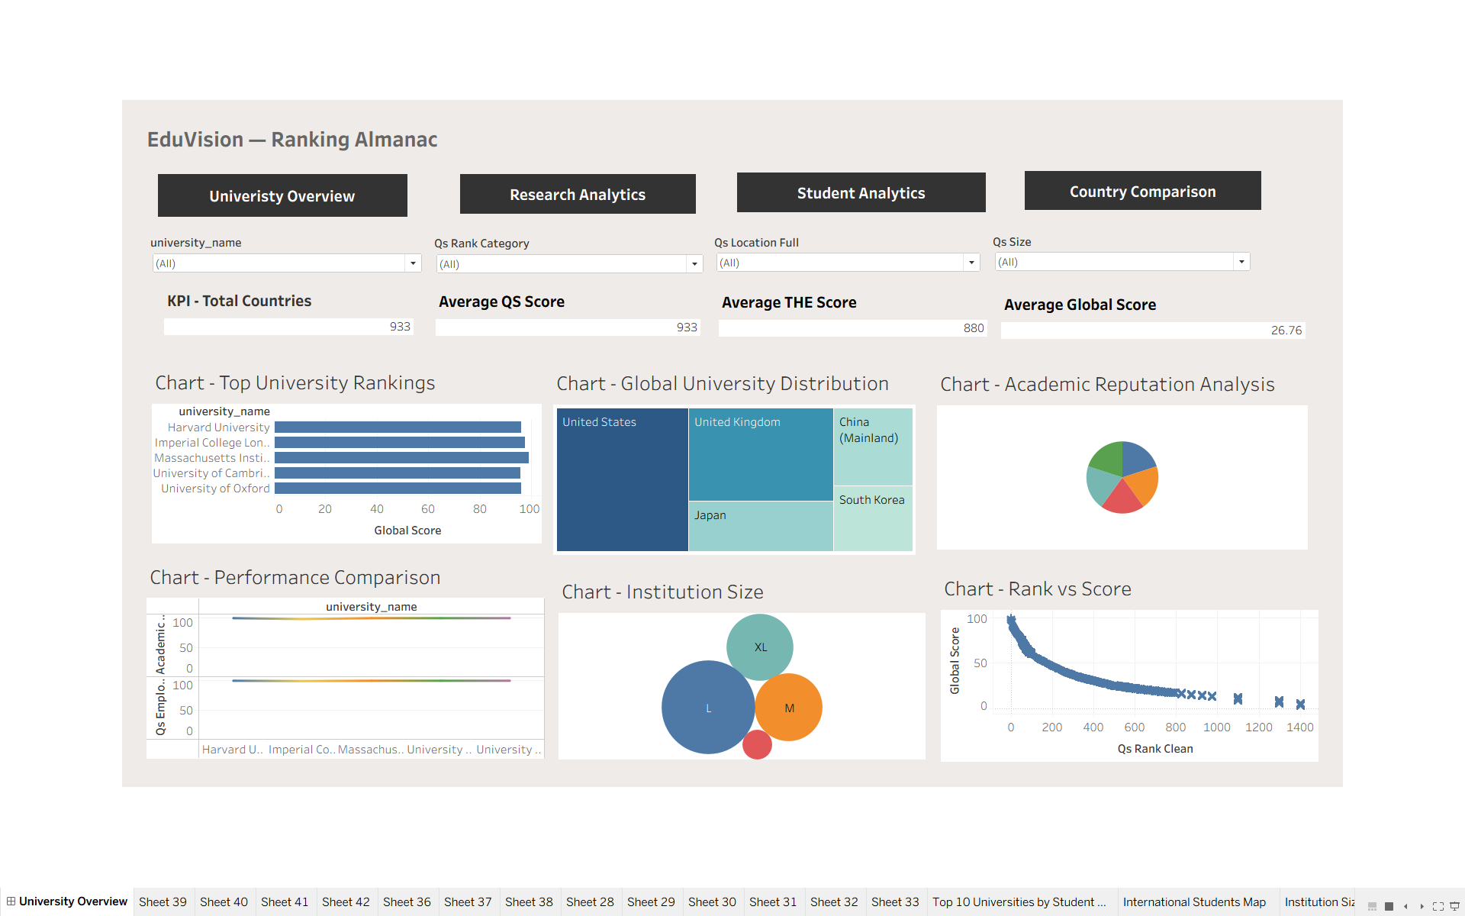
Figure 1. University Overview Dashboard — overall ranking, global score, academic reputation, institution size, and rank-versus-score analysis.

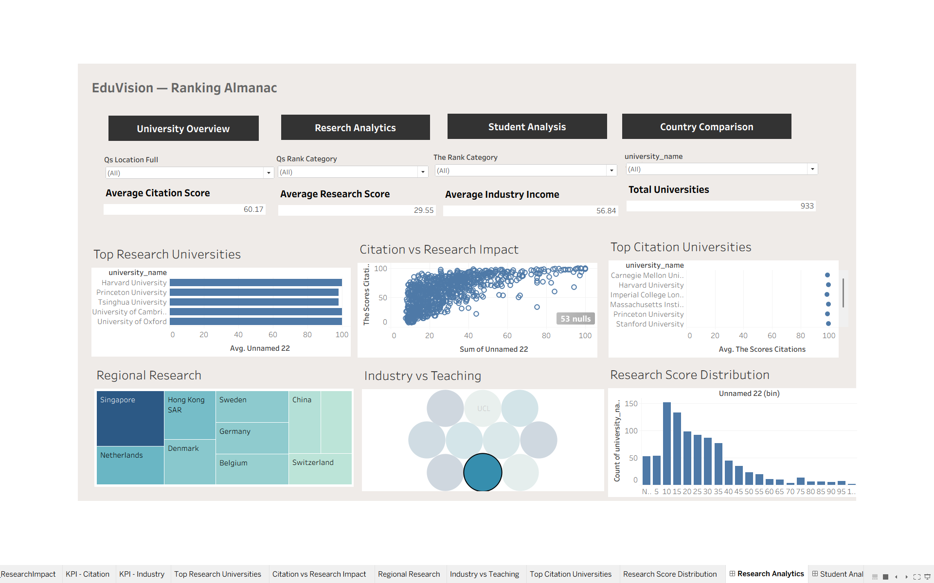
Figure 2. Research Analytics Dashboard — research score, citation impact, industry income, teaching score, and research distribution.

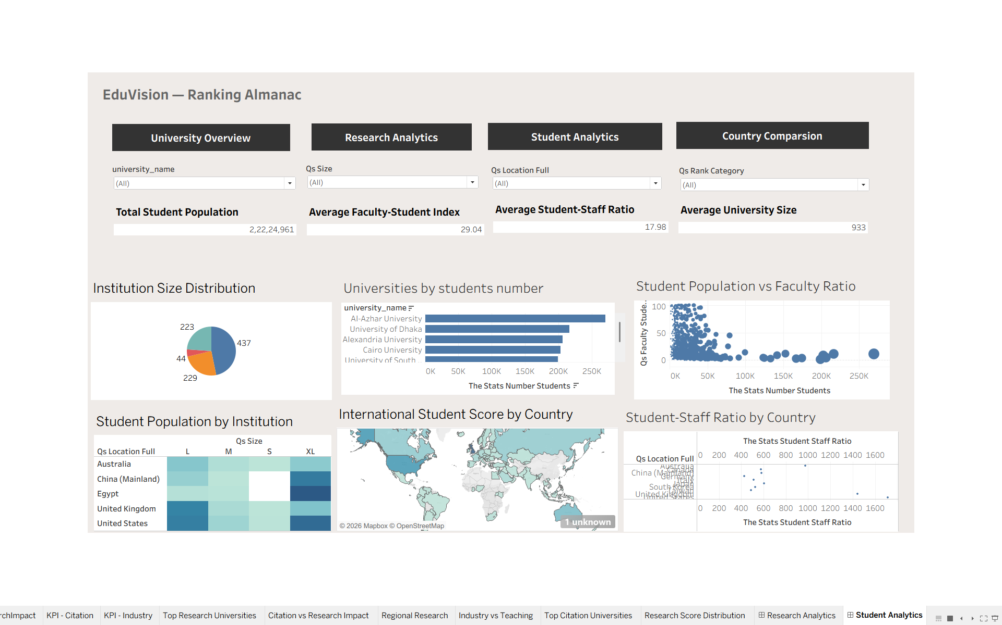
Figure 3. Student Analytics Dashboard — student population, institution size, faculty-student indicators, student-staff ratio, and country map.

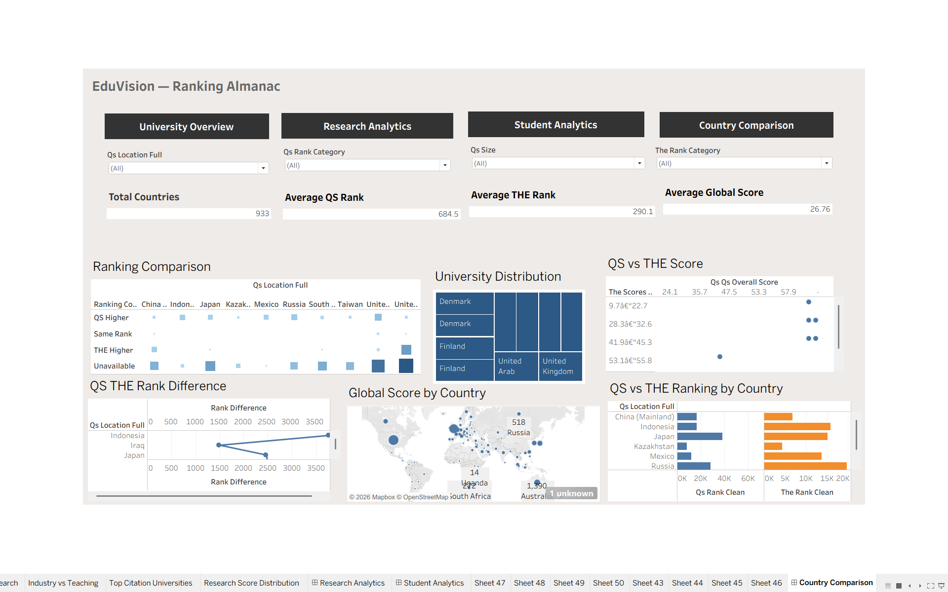
Figure 4. Country Comparison Dashboard — QS/THE country comparison, rank difference, global score, university distribution, and ranking classification.

10. Technical Implementation

10.1 Data Processing Script
The main Python analysis workflow uses Pandas and NumPy for data manipulation. It loads the merged QS/THE dataset, standardizes column names, cleans university names, removes duplicates, parses rank ranges, creates derived fields, calculates KPIs, generates exploratory charts, and exports the final cleaned dataset.

10.2 Rank Parsing
QS and THE can contain rank ranges such as 601–610 and open-ended values such as 1501+. The project converts these values into numeric estimates so they can be plotted and compared. Range values are represented using their midpoint, while non-ranked Reporter values are treated as unavailable for numeric rank calculations.

10.3 Derived Analytical Fields
- qs_rank_clean — numeric QS rank used for analysis.
- the_rank_clean — numeric THE rank used for analysis.
- rank_difference — THE rank minus QS rank.
- absolute_rank_difference — absolute size of the ranking difference.
- qs_rank_category — QS ranking band.
- the_rank_category — THE ranking band.
- ranking_comparison — QS Higher, THE Higher, Same Rank, or Unavailable.
- university_name — unified university display field.
- academic_reputation_score — QS academic reputation indicator.
- faculty_student_ratio_score — QS faculty-student indicator.
- global_score — weighted QS indicator score used by the project.

10.4 Tableau Implementation
- Each dashboard is assembled from separate worksheets.
- KPIs are built as individual summary worksheets and placed at the top of the dashboard.
- Filters are added at dashboard level and applied to relevant worksheets.
- Navigation objects connect the four dashboard pages.
- Background formatting, typography, titles, and spacing are kept consistent across dashboards.
- Different chart types are used to reduce repetition and support different analytical questions.

11. Results and Key Observations
The completed project converts the university ranking dataset into an interactive analytical environment. The four dashboards collectively provide multiple views of the same underlying dataset.
- The University Overview provides a consolidated entry point for ranking and score analysis.
- The Research Analytics dashboard separates research, citation, teaching, and industry-income indicators.
- The Student Analytics dashboard provides both institution-level and country-level views of student characteristics.
- The Country Comparison dashboard makes QS and THE differences easier to inspect by country and institution.
- Interactive filters allow users to narrow the analysis by university, country, ranking category, and institution size where configured.
- Python-generated exploratory charts were used to validate relationships and distributions before/alongside Tableau development.
- The final dashboards provide a presentation-ready business intelligence layer over the cleaned dataset.

Exploratory Analysis Highlights
- The QS-versus-THE scatter analysis shows a positive relationship between the two ranking positions, while also revealing notable differences for individual institutions.
- The rank-difference distribution is concentrated around smaller differences but contains substantial outliers.
- Most institutions in the dataset fall into broader ranking categories such as Above 500 and 101–500.
- Country-level counts show that the dataset has a strong concentration of institutions in a subset of countries.
- Research and citation visualizations reveal variation in institutional research-related performance across universities.

12. Limitations
- The dataset does not provide a single consistent Year field for all dashboard analyses, so the final Tableau dashboards do not use the reference report's year filter.
- The dataset uses available QS and THE fields; missing or unavailable rankings may appear as Unknown/Unavailable in derived categories.
- Rank ranges are converted to numeric estimates for plotting, which means a range is represented by an approximate midpoint rather than every possible rank.
- Some student-related indicators depend on the availability and quality of the source fields.
- Country comparison is based on the country/location field available in the dataset rather than an independently constructed geographic-region hierarchy.
- The dashboards are analytical and descriptive; they do not establish causal relationships between ranking indicators.

13. Future Scope
- Add a consistent historical year dimension to support year-over-year ranking analysis.
- Integrate additional ranking systems and subject-level rankings.
- Add regional hierarchies such as continent and geographic region for deeper geographic analysis.
- Introduce predictive analytics for future ranking movement using historical data.
- Add drill-down interactions from country to university and from university to individual indicators.
- Publish the dashboards through Tableau Server/Cloud for wider access.
- Add automated refresh pipelines so new ranking releases can update the dashboards with minimal manual work.
- Extend the project with more advanced statistical analysis of ranking agreement and indicator relationships.

14. Conclusion
EduVision successfully transforms QS and THE university ranking information into a structured analytics solution. The project combines Python-based preparation and analytical processing with Tableau-based interactive visualization.
The four dashboards provide complementary perspectives: University Overview for high-level performance, Research Analytics for research and impact indicators, Student Analytics for student and institution characteristics, and Country Comparison for geographic and QS/THE comparison. Together, they create a unified ranking-analysis environment suitable for exploration, presentation, and further extension.
The project demonstrates an end-to-end data analytics workflow covering data collection, cleaning, transformation, KPI calculation, visualization, dashboard design, and analytical interpretation.

Appendix A — Project Files
- data_collection.py — Module 1 data collection/loading script.
- university_raw_data.csv — raw university dataset output.
- university_rankings_analysis.py — main cleaning and exploratory analysis workflow.
- kpi_calculations.py — KPI field generation and enriched dataset export.
- final_cleaned_university_dataset.csv / .xlsx — cleaned dataset used for Tableau.
- University_Rankings_QS_THE_Analysis.ipynb — notebook version of the analysis workflow.
- Tableau workbook — interactive dashboards and supporting worksheets.

Appendix B — Dashboard Navigation
- University Overview → Research Analytics
- Research Analytics → Student Analytics
- Student Analytics → Country Comparison
- Country Comparison → University Overview

